**Ideation Phase**

**Define the Problem Statement**

|  |  |
| --- | --- |
| Date | 25 November 2025 |
| Team ID |  |
| Project Name | DocSpot |
| Maximum Marks | 2 Marks |

**Problem statement:**

Patients often struggle to find the right doctors, check their availability, and book appointments without unnecessary delays. Most clinics still rely on manual or outdated scheduling systems, which lead to miscommunication, long waiting times, and a lack of transparency in appointment management. Doctors also face difficulties managing their schedules efficiently, while administrators handle repetitive tasks without a centralized digital platform. This results in frustration for patients, inefficiency for doctors, and operational challenges for clinic staff. DocSpot aims to solve these issues by providing a seamless, real-time, and user-friendly appointment booking system.

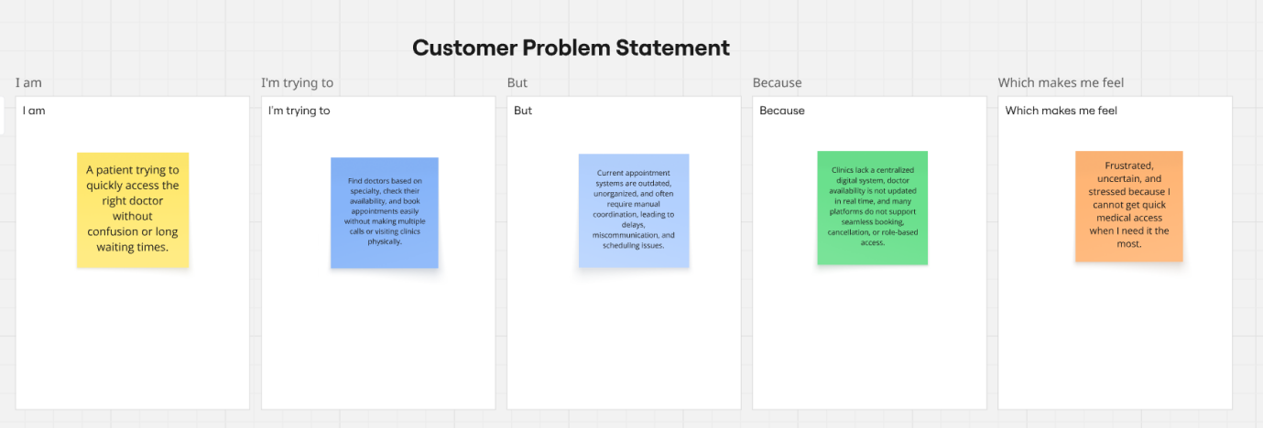

# **Customer Problem Statement 1: Patient**

### **I am**

A patient looking for quick and reliable access to the right doctor.

### **I’m trying to**

Book appointments easily, check doctor availability, and avoid long clinic waiting times or repeated phone calls.

### **But**

Most clinics use manual or outdated systems that cause delays, confusion, and difficulty finding the right specialist.

### **Because**

There is no centralized digital platform that shows real-time availability, doctor details, or quick booking options.

### **Which makes me feel**

Frustrated, stressed, and uncertain about when I can actually see a doctor.

# **Customer Problem Statement 2: Doctor**

### **I am**

A doctor trying to manage my consulting schedule and patient appointments efficiently.

### **I’m trying to**

Organize appointments, reduce no-shows, and view all bookings in one place without depending on staff updates.

### **But**

Manual scheduling leads to miscommunication, double bookings, and time conflicts with clinic and online consultations.

### **Because**

There is no automated system that syncs schedules, manages appointments, or provides easy access to patient booking details.

### **Which makes me feel**

Overloaded, unorganized, and unable to provide a smooth experience for my patients.